**Junior Design Project Report**

**CSE 299 (**Section: 12**)**

**A Complete System to Detect, Stop Cyberbullying Along with AI-Supported Mental Health Counselling Chatbot.**



**Submitted By**

Name: Farhan Ishrak Tahmid (ID: 2031458642)

Name: Farhana Akbar (ID: 2012482042)

**Supervisor**

Dr. Ahsanur Rahman

Associate Professor

**ELECTRICAL AND COMPUTER ENGINEERING**

**NORTH SOUTH UNIVERSITY**

Spring 2023

**Agreement Form**

We take great pleasure in submitting our Junior Design project report on “**A Complete System to Detect, Stop Cyberbullying Along with AI-Supported Mental Health Counselling Chatbot**.”. This report is prepared as a requirement of the Junior Design Project CSE299 which is a one semester long design course. This course involves teams of students who build and test IOT devices, web applications, mobile apps or engineering processes. Design projects are selected from proposal submitted by the students, or recommended by the course instructor, or text book design problems.

We would like to request you to accept this report as a partial fulfillment of Bachelor of Science degree under Electrical and Computer Engineering Department of North South University.

**Declared By:**

………………………………………………

Name: Farhana Akbar

ID: 2012482042

………………………………………………

Name: Farhan Ishrak Tahmid

ID: 2031458642

**Approved By:**

……………………………

Supervisor

Dr. Ahsanur Rahman

Assistant Professor, Department of Electrical and Computer Engineering

North South University, Dhaka, Bangladesh

.......................................

Dr. Rajesh Palit

Professor & Chair, Department of Electrical and Computer Engineering

North South University, Dhaka, Bangladesh

**A Complete System to Detect, Stop Cyberbullying Along with AI-Supported Mental Health Counselling Chatbot.**

**Abstract:**

Cyberbullying has become a pervasive issue in today's digital age, impacting individuals across various demographics and platforms. To address this pressing concern, this research proposes a comprehensive system that collaborates with institutions and organizations to detect cyberbullying incidents, maintain detailed records of victims and bullies, and take centralized actions when necessary. Moreover, the system incorporates personalized counseling services to provide tailored support and guidance to victims, helping them cope with the emotional and psychological consequences of cyberbullying.

The proposed system aims to tackle cyberbullying from multiple angles, leveraging advanced technologies and partnerships to create a safer and more inclusive online environment. By working closely with educational institutions, social media platforms, and law enforcement agencies, the system can effectively identify and address cyberbullying cases in their various forms, including harassment, threats, and online defamation.

The detection component of the system utilizes state-of-the-art algorithms and machine learning techniques to monitor online activities and identify potential instances of cyberbullying. It analyzes text, images, and videos across different platforms, scanning for offensive language, abusive behavior, or patterns indicative of cyberbullying. When a potential case is detected, the system automatically generates a report and initiates appropriate actions based on predefined protocols.

Centralizing the management of cyberbullying incidents is a crucial aspect of the proposed system. By maintaining a comprehensive database of victims and bullies, the system ensures that no case goes unnoticed or unaddressed. The database records relevant information, such as the identities of individuals involved, the nature of the incident, and any available evidence. This consolidated information enables authorities to take swift and appropriate actions, such as issuing warnings, imposing sanctions, or involving law enforcement, depending on the severity of the incident.

Recognizing the profound impact of cyberbullying on victims, the proposed system provides personalized counseling services as an integral part of the intervention process. Trained professionals and mental health experts are employed to offer empathetic support, guidance, and therapeutic interventions to victims. Through confidential online sessions, victims can discuss their experiences, receive emotional support, and learn coping mechanisms to navigate the challenges posed by cyberbullying. The system ensures that victims receive personalized attention, tailoring counseling sessions to address their specific needs and concerns.

Furthermore, the proposed system emphasizes preventive measures by engaging in proactive educational initiatives. It collaborates with schools, community organizations, and online platforms to raise awareness about cyberbullying, promote digital literacy, and encourage responsible online behavior. By educating individuals about the consequences of cyberbullying and fostering a culture of empathy and respect, the system aims to create a long-lasting impact in reducing cyberbullying incidents.

In conclusion, the proposed system represents a comprehensive approach to combat cyberbullying. By integrating detection mechanisms, centralized intervention procedures, and personalized counseling services, it aims to provide a holistic solution for addressing this pervasive issue. Through collaboration with institutions and organizations, the system can create a safer and more inclusive digital landscape, empowering individuals to navigate the online world without the fear of cyberbullying.

**Table of Contents**

Table of Contents

**Chapter 1** 9

**Overview** 9

**1.1** **Introduction** 10

**1.2 Project definition** 10

**1.3 Purpose of our Project/ Motivation** 10

**1.4 Project Goal** 10

**1.5 Summary** 10

**Chapter 2** 11

**Existing Systems and Solution Adopted** 11

**2.1 Introduction** 12

**2.2 Existing Solution** 12

**2.3 Proposed Solution** 12

**2.4 Solution Adopted and Reasons** 12

**2.5 Summary** 12

**Chapter 3** 13

**Technical description & Implementation** 13

**3.1 Introduction** 14

**3.2 Database** 14

**3.3 UI** 15

**3.4 Backend** 15

**3.5 API** 15

**Chapter**  **4** 17

**Results and Discussion** 17

**Chapter**  **5** 19

**Conclusion** 19

**List of Tables**

[Auto generate using MS WORD]

**List of Figures**

[Auto generate using MS WORD]

# **CHAPTER 1**

# **INTRODUCTION**

* 1. **Project Statement:**

The objective of this project is to develop a comprehensive system that combines advanced technologies to detect and prevent cyberbullying, while also incorporating an AI-based mental health counseling system. The project aims to create a safer and more supportive digital environment for individuals, especially those vulnerable to the harmful effects of cyberbullying.

The core focus of our project is the development of a sophisticated cyberbullying detection system. Leveraging deep learning and machine learning models, we aim to create an algorithm capable of identifying and flagging instances of cyberbullying across multiple platforms and communication channels. This system will employ advanced text analysis techniques to detect patterns of harmful behavior and provide timely intervention.

In addition to the detection system, we will integrate an AI-based mental health counseling system within our project. Recognizing the emotional toll that cyberbullying can have on individuals, we believe that offering accessible and personalized mental health support is crucial. Through natural language processing and sentiment analysis, our counseling system will provide empathetic and helpful responses to individuals seeking assistance, guiding them towards appropriate resources and coping strategies.

To implement the project, we will utilize Django as the backend framework, enabling efficient data handling and storage using a SQLite3 database. The frontend application will be developed using the Flutter framework, ensuring a seamless and user-friendly experience across multiple platforms, including web, Android, iOS, Windows, and Linux.

To maximize the impact of our system, we have decided to focus our implementation efforts within organizations, offices, and institutions. This targeted approach allows us to establish better control and monitoring mechanisms, ensuring the enforcement of anti-cyberbullying policies. Collaborating closely with these entities, we will customize the system to align with their specific needs and integrate it seamlessly into their existing workflows.

Throughout the project, we will continuously evaluate and refine our system based on user feedback, emerging trends, and advancements in technology. Our goal is to create a robust and scalable solution that not only detects and prevents cyberbullying but also provides meaningful support to individuals affected by it. By doing so, we aspire to foster a more compassionate and inclusive digital society where individuals can thrive free from the fear of cyberbullying.

* 1. **Motivation:**

The motivation for creating a cyberbullying detection system stem from the alarming prevalence and harmful impact of cyberbullying incidents in today's digital society. Cyberbullying has emerged as a significant social issue, affecting individuals of all ages, backgrounds, and demographics. It poses serious consequences for victims, including emotional distress, psychological harm, decreased self-esteem, and even the risk of self-harm or suicide specially in educational institutions.

Traditional approaches to combating cyberbullying often fall short due to the rapidly evolving nature of online platforms and the sheer volume of online interactions. As a result, there is a pressing need for an advanced and comprehensive system that can effectively detect and address cyberbullying incidents in real-time.

The motivation for creating such a system also stems from the recognition that cyberbullying is a complex issue requiring a multifaceted approach. By integrating advanced technologies, machine learning algorithms, and artificial intelligence, the system can analyze vast amounts of online data to identify patterns, detect early warning signs, and differentiate between harmless interactions and harmful cyberbullying incidents. This enables authorities to intervene more effectively and efficiently, taking appropriate actions to address and prevent future instances of cyberbullying.

* 1. **Background Research**

Cyberbullying has emerged as a significant concern in the digital age, with detrimental effects on individuals' mental health and overall well-being. As technology continues to advance, there is a pressing need to develop effective solutions to detect and prevent cyberbullying, while also providing necessary support to those affected. In conducting our background research, we sought to explore existing studies, research papers, and applications related to this topic.

1. Research Studies: Numerous research studies have investigated cyberbullying and its impact on individuals. These studies delve into the various forms and manifestations of cyberbullying, its prevalence across different demographics, and the psychological and emotional consequences experienced by victims. Researchers have also examined the role of technology and social media platforms in facilitating cyberbullying incidents. Some research papers and Journals are given bellow:

* "Detecting Cyberbullying in Social Media" by Salminen et al. (2018):

Approach: The authors proposed a method based on machine learning techniques to detect cyberbullying in social media. They utilized features such as linguistic patterns, user interactions, and content characteristics to train a classifier that could identify cyberbullying instances.

* "Cyberbullying Detection in Social Media Texts" by Zhang et al. (2018):

Approach: This study focused on the development of a deep learning model using convolutional neural networks (CNN) and long short-term memory (LSTM) to automatically detect cyberbullying in social media text. The model extracted text features and employed classification algorithms to identify instances of cyberbullying.

* "A Machine Learning Approach for the Detection of Cyberbullying" by Chawla et al. (2018):

Approach: The researchers utilized machine learning algorithms, including decision trees and support vector machines, to classify social media content and identify cyberbullying instances. They leveraged features such as text sentiment, lexical patterns, and user interaction data for accurate detection.

* "Deep Learning for Cyberbullying Detection on Twitter" by Chatzakou et al. (2017):

Approach: This study employed deep learning techniques, including recurrent neural networks (RNN) and convolutional neural networks (CNN), to detect cyberbullying on Twitter. The models were trained on a large dataset of annotated tweets and achieved high accuracy in identifying cyberbullying content.

* "Detecting Cyberbullying on Social Media Using Machine Learning Techniques" by Agarwal et al. (2018):

Approach: The authors employed machine learning techniques, such as logistic regression and random forest, to classify social media posts and detect cyberbullying. They utilized features like textual patterns, sentiment analysis, and contextual information to train the classifiers.

2) Existing Softwares:

* [Bully Button:](https://play.google.com/store/apps/details?id=com.wli.bbparentkid&hl=en&gl=US&pli=1) Bully Button is a handy application that allows users to flag and alert instances of online harassment through a simple and effective alert framework.
* [ReThink](https://play.google.com/store/apps/details?id=com.rethink.app.rethinkkeyboard&hl=en&gl=US): The intention behind ReThink is to prevent instances of cyberbullying before they have even occurred. The app flags messages that have been predetermined to contain hateful or abusive content and offers senders the chance to reword or reconsider their messages. Users then have to clear their choice of words. This extra encouragement to reflect on word choice could go a long way in preventing cyberbullies from hurting others.
* [BulliBlock](https://www.amazon.com/Spy-Parent-LLC-Bully-Block/dp/B004WG0I2S): Bully Block is a free app designed to help young people deal with bullying when it does occur. Users can discreetly record and capture instances of harassment and use their evidence to report to responsible adults. Users can easily record their harassers and catch them in the act. Users can also block certain content, such as harassment or abusive language. Everything that users record will be saved onto your device’s SD card, meaning it can be presented as evidence to the appropriate authorities!
* [Take a Stand Together](https://download.cnet.com/Take-a-Stand-Together/3000-20414_4-78415473.html): This app was developed by the Australian educational authority to tackle the issue of cyberbullying among school children. Take a Stand Together provides its users with a host of handy tips, resources, and support that they can use in the occurrence of harassment. The app offers young people stories, advice, and animated clips that explain bullying in various forms.

# **CHAPTER 2**

# **PROJECT PLAN**

* 1. **Timeline & Work-Division:**

|  |  |  |
| --- | --- | --- |
|  |  |  |
| Task | **Start - End** | **Assigned To** |
|  |  |  |
|  |  |  |
|  |  |  |
|  |  |  |
|  |  |  |
|  |  |  |
|  |  |  |
|  |  |  |
|  |  |  |
|  |  |  |
|  |  |  |

# **CHAPTER 3**

# **PROJECT DESIGN & IMPLEMENTATION**

* 1. **Tools Used:**

**Table 2.1: Description of Tools**

|  |  |  |  |
| --- | --- | --- | --- |
| **Tool** | **What it does** | **Other similar Tools (if any)** | **Why selected this tool** |
| **Django** | Django is a high-level web framework for building web applications in Python. It provides a set of tools and libraries that simplify the process of building complex, database-driven websites. Django follows the Model-View-Controller (MVC) architectural pattern, although it refers to it as the Model-View-Template (MVT) pattern. | **Laravel, Next JS, Express JS** | Django is a full-featured web framework for Python known for its rapid development, scalability, security, and extensive documentation. It provides built-in features, a large community, and a rich ecosystem, easy to deploy ML models, making it a popular choice for building complex web applications efficiently. However, other existing Framework lack some of these abilities, that is why we chose Django |
| **Django-Rest Framework- API** | Django REST Framework (DRF) is a powerful and flexible toolkit for building Web APIs in Django. It is an extension of Django that provides additional functionality specifically tailored for creating RESTful APIs. DRF includes features such as serialization, authentication, permissions, viewsets, and serializers, making it easier to build robust and scalable APIs. It follows best practices and standards for API development and integrates seamlessly with Django, allowing developers to create RESTful APIs efficiently. | **FastAPI, Tornado, Pyramid** | We chose Django-Rest-Framework over other API frameworks because:   * + Seamless integration with Django, leveraging existing knowledge and codebase.   + Comprehensive features tailored for building RESTful APIs, reducing development effort.   + High customizability, allowing developers to adapt the framework to specific project requirements.   + Excellent documentation and a strong community for support and resources. |
| **OpenAI API**  **(Davinci engine)** | OpenAI API is a powerful tool that allows developers to integrate OpenAI's state-of-the-art language models, like GPT-3, into their own applications. By making API requests, developers can leverage the language model's capabilities for tasks such as generating natural language text, answering questions, creating conversational agents, translating languages, and much more. The OpenAI API enables access to cutting-edge language processing technology, enabling developers to build innovative and intelligent applications. | Google Bard | Google Bard is not providing api’s publicly right now. Morver, OpenAI’s language models are more trained and can hold conversation like a natural human being. |
| **Flutter** | Flutter is an open-source UI toolkit developed by Google for building natively compiled applications for mobile, web, and desktop platforms using a single codebase. It uses the Dart programming language and provides a rich set of pre-designed widgets that allow for fast and beautiful cross-platform app development. Flutter's hot-reload feature enables real-time code changes and instant updates, enhancing the developer's productivity. It has gained popularity for its performance, flexibility, and the ability to create visually appealing and responsive user interfaces. | React-native, Ionic, Xamarin | We wanted to implement our project and manage it from a single codebase for Android, iOS, macOS, Linux, Windows. To support all these platforms we used Flutter. Moreover, its robust UI development was really important for us. |
| **Bnlp-toolkit** | The BNLP Toolkit is a Python library that provides a set of natural language processing (NLP) functionalities specifically designed for the Bengali language. It offers various features such as tokenization, named entity recognition, part-of-speech tagging, sentiment analysis, text classification, and more. The BNLP Toolkit aims to simplify NLP tasks for Bengali text processing, allowing developers and researchers to work with Bengali language data effectively. It provides an accessible and convenient way to perform NLP tasks and analysis on Bengali text within the Python programming environment. | NLTK, Spacy, Hugging Face Transformers. | The BNLP Toolkit is specifically designed for Bengali language processing, providing dedicated functionalities and resources tailored to the Bengali language. Choosing the BNLP Toolkit over others ensures more accurate and efficient NLP tasks for Bengali text, saving time and effort in developing language-specific solutions. |
| **pytesseract** | Pytesseract is a Python wrapper for the Tesseract OCR engine, which is an open-source optical character recognition (OCR) tool. It provides a convenient way to extract text from images or scanned documents using Tesseract's capabilities. Pytesseract simplifies the integration of OCR functionality into Python applications by providing a straightforward API. It supports multiple languages and can be used for tasks such as extracting text from images, processing scanned documents, and automating data extraction from various sources. | Google Image to text API, Textract, Microsoft Azure OCR | Most of the alternatives are paid and highly expensive. Also, py-tesseract remains embedded in the system. This is why it runs on the system internally, therefore a wait free Image to Text Conversion is done. |
| **Visual Studio Code** | Visual Studio Code (VS Code) is a lightweight and highly customizable source code editor developed by Microsoft. It is available for Windows, macOS, and Linux, and supports various programming languages and frameworks. VS Code offers a rich set of features including syntax highlighting, code autocompletion, debugging capabilities, version control integration, and an extensive ecosystem of extensions. It provides a user-friendly interface and a wide range of customization options, making it a popular choice among developers for its versatility and productivity-enhancing features. | PyCharm, Sublime Text, Atom, Notepad++ | We chose VS Code because of its extensive customization options, and a vast ecosystem of extensions. Its versatility, user-friendly interface, and powerful features make it a popular choice for developers seeking a highly productive and adaptable coding environment. |
| **Git** | Git is a distributed version control system widely used for managing source code and tracking changes in software development projects. It allows multiple developers to collaborate on a project by keeping a history of changes, branches, and merges. Git provides features like commit tracking, branching, merging, and remote repository synchronization. It helps teams work concurrently, revert to previous versions, resolve conflicts, and maintain a consistent codebase across different environments. Git is known for its speed,flexibility,and robustness, making it a popular choice among developers for version control. | Mercurial, SVN, Bazaar. | We chose Git for version control due to its widespread adoption, speed, flexibility, and robustness. It offers powerful branching and merging capabilities, efficient handling of large codebases, and seamless collaboration among developers. Git's popularity is attributed to its excellent support, extensive ecosystem, and ability to handle both small and large-scale projects effectively.se, |

**Table 2.2: Sources of Tools**

|  |  |  |
| --- | --- | --- |
| **Tool** | **Source** | **Cost (if any)** |
| **Django** | Python Package installer PIP.  Terminal Command: pip3 install Django | **N/A** |
| **Django-Rest Framework** | Python Package installer PIP.  Terminal Command: pip3 install djangorestframework | **N/A** |
| **OpenAI API** | Terminal Command: pip3 install openai  Platform: <https://platform.openai.com/> | **$5.00 for signing up,**  **Pay as you go Method** |
| **Flutter** | Platform: <https://docs.flutter.dev/get-started/install/windows> | **N/A** |
| **Bnlp-toolkit** | Terminal Command: pip3 install bnlp-toolkit  Platform: <https://pypi.org/project/bnlp-toolkit/> | **N/A** |
| **pytesseract** | Terminal Command: pip3 install pytesseract |  |
| **Visual Studio Code** | Platform: <https://code.visualstudio.com/docs/?dv=win> | **N/A** |
| **Git** | Platform: <https://git-scm.com/download/win> | **N/A** |

* 1. **Technical Design**

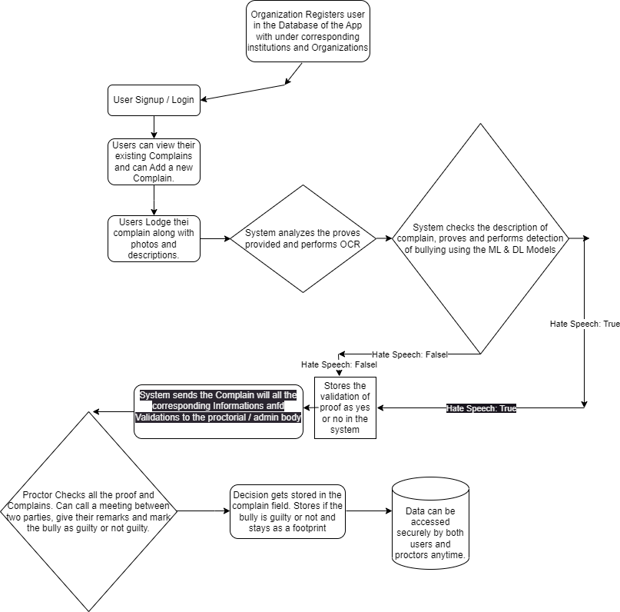

System Diagram

* 1. **Implementation**

We have developed our system in two parts.

In the first part, we created a Backend Server using Django, which efficiently processes incoming requests. Python served as the primary language for our Backend server. We utilized a Sqlite3 database for data handling and storage, following the Django Object-Relational Model (ORM) to interact with the database. All data operations such as inputting, updating, deleting, and creation were implemented using the Object-Oriented Programming approach. Additionally, we integrated our Deep Learning and Machine Learning models into the backend server. Our backend system also performs Image to Text conversion. We established API endpoints to facilitate constant communication between our Frontend Application and Backend Server, collecting and processing data from the frontend.

For the second part, we developed our Frontend Application using the Flutter Framework, enabling us to create a versatile application for Web, Android, iOS, Windows, and Linux platforms. We established a connection between our Frontend Application and Backend Server through APIs. In the Flutter application, we collected user data and sent it to the Backend Server for processing.

To achieve high accuracy in detecting Bangla and English Hate Speech, we implemented various Machine Learning and Deep Learning models. For Bangla Hate Speech detection, we employed models such as Linear SVM, Naïve Bayes, Random Forest Classifier, Logistic Regression, and Sequential Models. Among them, the Sequential Model achieved the highest accuracy of 83.27%. Sequential Models are widely recognized for their effectiveness in Natural Language Processing tasks. For English Hate Speech Detection, we used models like Naïve Bayes, Linear SVM, and Decision Tree Models. Our highest accuracy of 96.37% was obtained using the Decision Tree Model.

To train our Machine & Deep Learning Models for Bangla Hate Speech Detection, we used “[Benglai Hate Speech Dataset](https://www.kaggle.com/datasets/naurosromim/bengali-hate-speech-dataset)” from Kaggle. We collected some data via Google Form also and used them with it.

For English HateSpeech detection we used a dataset named “[Cyber Bullying Dataset](https://www.kaggle.com/datasets/saurabhshahane/cyberbullying-dataset)”, which is mainly a Twitter Parsed Dataset. We also added some of our Google Form data with it.

* 1. **Availability:**

Github Link: <https://github.com/FarhanTahmid/CyberBullying-Detection-Prevention-Counseling-System>

# **CHAPTER 4**

# **PROJECT DESCRIPTION**

SignUp:

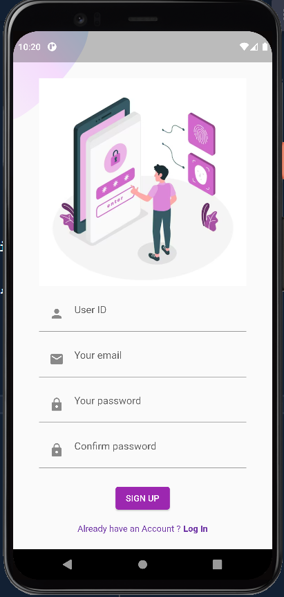

For new user, they have to SignUp with a -User ID

-Email

-Creating new password.

Login:

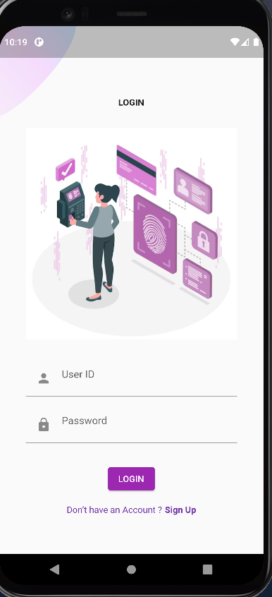

To Login user needs

-User ID

- Password.

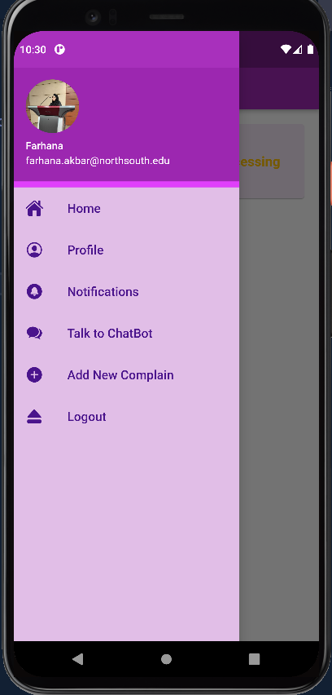Nav Bar:

In nav bar section,

We’ll see these features-

* Home
* Profile
* Notification
* Talk to ChatBot
* Add New Complain
* Logout

# Homepage:

# 

Home page contains all the complains that user posted.

# 

When the complain card is clicked, it’ll show the complaint details.

# 

Profile:

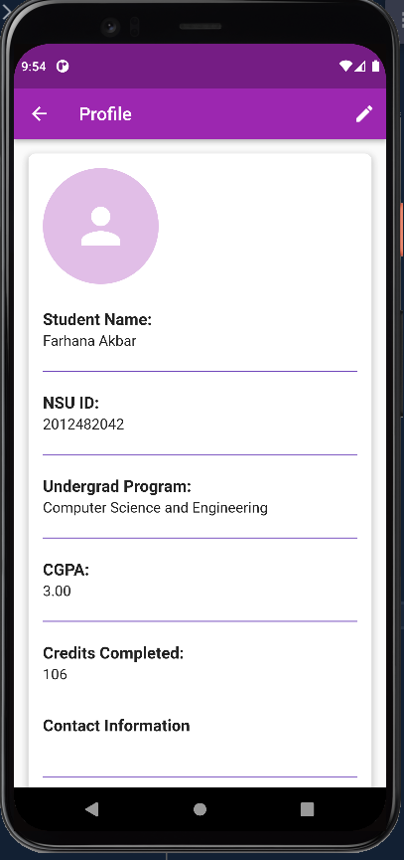

User can Edit and save their student profile.

Notifications:

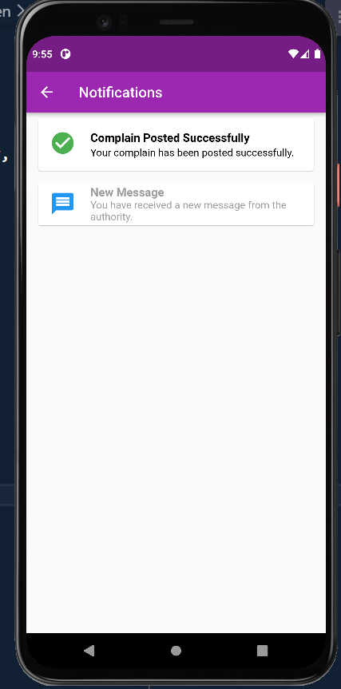

All the notifications related to complain will show here.

Talk to ChatBot:

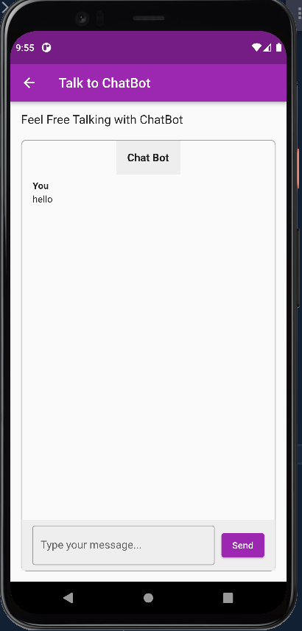

Victim has a support system. It’s for their consultation. AI chat bot will make sure victim gets proper answers to every messages.

Add New Complain:

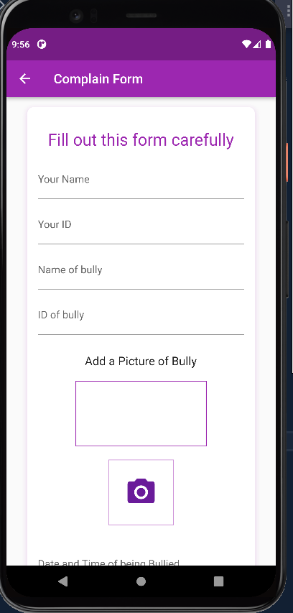

To create new complain, user must fill-up the form with valid informations.

Proctor’s view:

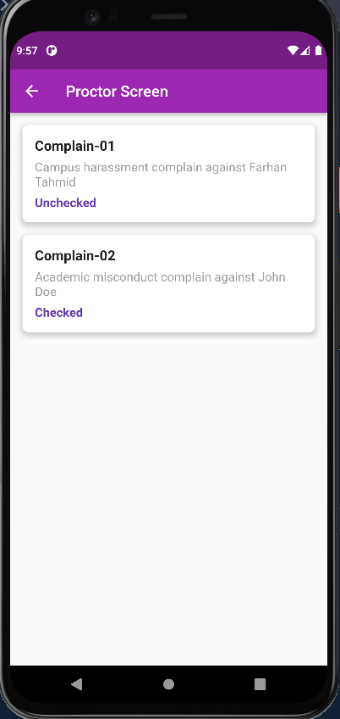

# 

Proctor Screen will show all the complains posted by students.

# 

All the details of a complain will show here.

Proctor can

-write his remarks.

- Call Parents for meeting

- Mark bully as guilty or not guilty.

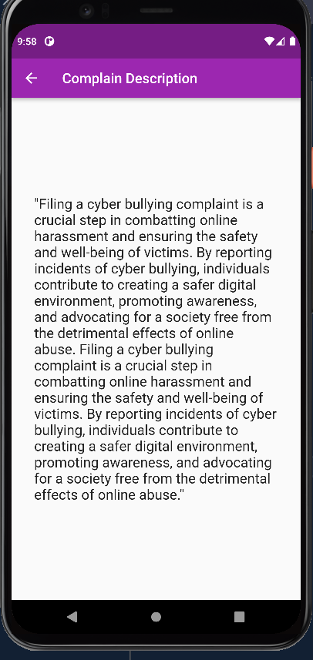

“See Description” shows the complain description written by victim.

# 

When “View Submitted Proves” button is clicked, it shows all the pictures that victim provided.

# 

“See Description” Proctor can call both parents for a meeting.

Message can be sent through mobile number according to scheduled date and time by proctor.

# 

# **CHAPTER 5**

# **PROJECT SUMMARY**

* 1. **Results and Comparison:**

From our research on the Internet we have not found anything that is a complete system to detect, stop cyber bullying and also a system for mental health counseling. I am attaching some of the existing applications that has been implemented in order to prevent cyber bullying:

1. [Bully Button:](https://play.google.com/store/apps/details?id=com.wli.bbparentkid&hl=en&gl=US&pli=1) Bully Button is a handy application that allows users to flag and alert instances of online harassment through a simple and effective alert framework.
2. [ReThink](https://play.google.com/store/apps/details?id=com.rethink.app.rethinkkeyboard&hl=en&gl=US): The intention behind ReThink is to prevent instances of cyberbullying before they have even occurred. The app flags messages that have been predetermined to contain hateful or abusive content and offers senders the chance to reword or reconsider their messages. Users then have to clear their choice of words. This extra encouragement to reflect on word choice could go a long way in preventing cyberbullies from hurting others.
3. [BulliBlock](https://www.amazon.com/Spy-Parent-LLC-Bully-Block/dp/B004WG0I2S): Bully Block is a free app designed to help young people deal with bullying when it does occur. Users can discreetly record and capture instances of harassment and use their evidence to report to responsible adults. Users can easily record their harassers and catch them in the act. Users can also block certain content, such as harassment or abusive language. Everything that users record will be saved onto your device’s SD card, meaning it can be presented as evidence to the appropriate authorities!
4. [Take a Stand Together](https://download.cnet.com/Take-a-Stand-Together/3000-20414_4-78415473.html): This app was developed by the Australian educational authority to tackle the issue of cyberbullying among school children. Take a Stand Together provides its users with a host of handy tips, resources, and support that they can use in the occurrence of harassment. The app offers young people stories, advice, and animated clips that explain bullying in various forms.

Our system provides an end-to-end solution under the control of an authority, whether it be an organization or an educational institution. This ensures that victims receive proper justice. Additionally, our application offers mental health counseling for those in need, providing a safe space for individuals who may not feel comfortable seeking in-person counseling. Users also have the option to chat with a ChatBot if they feel lonely and simply need someone to talk to. Our project maintains a record of user activity, serving as a footprint that can be utilized in the future for both bullies and victims. By doing so, we aim to raise awareness in society, prevent cyberbullying, and protect potential victims.

Experimental result for our Machine & Deep Learning Models, OCR system results are given below as

Screnshots:

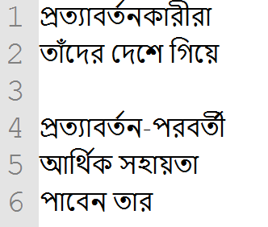 

Image to text Result for Bangla Language

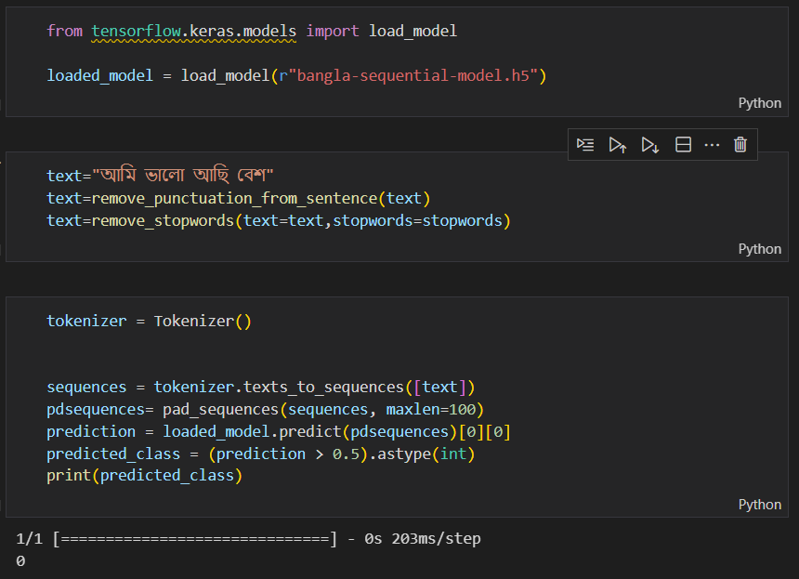

Deep Learning Result for Bangla Sequential Model

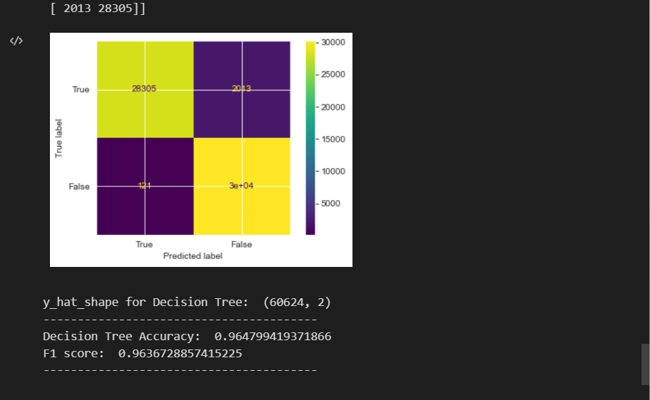

Accuracy for Sequential Model for English Hate Speech

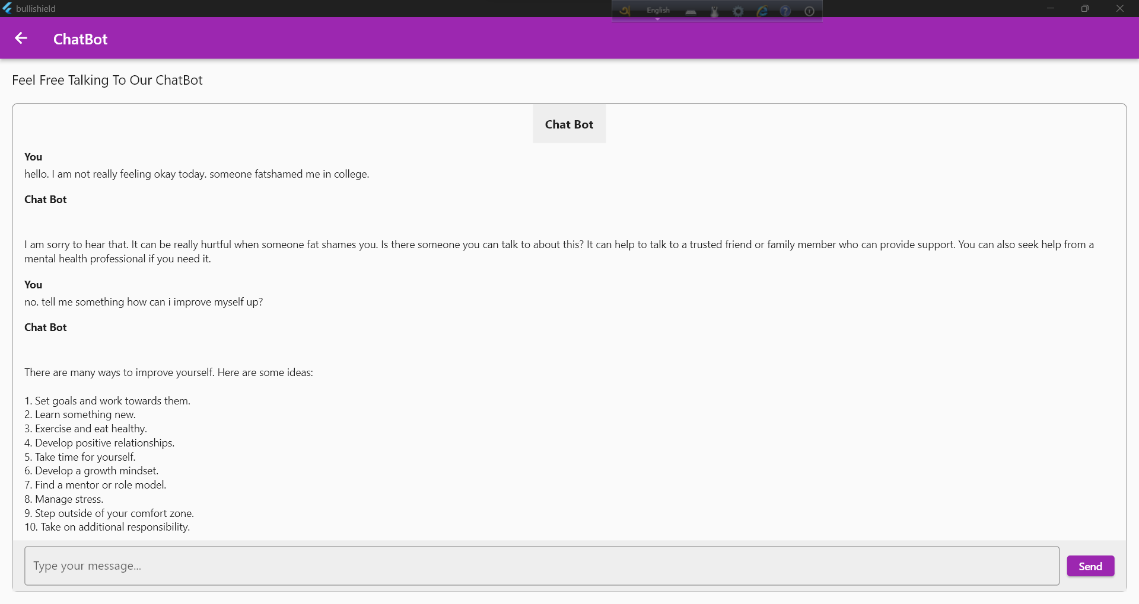

ChatBot implementation for Mental Health Counseling

The product we have developed is superior to others due to its easy-to-understand features, scalability, easy implementation, and effective planning. We address various aspects of cyberbullying, including detection, reporting, counseling, and raising awareness. This approach enables us to provide immediate support and assistance to victims, take appropriate actions against bullies, and educate the community about the consequences of cyberbullying. By offering counseling services and creating a safe environment for victims to seek help, we aim to empower individuals and ensure they receive the necessary support to overcome the emotional challenges associated with cyberbullying. Additionally, maintaining a record of user activity allows for the identification and tracking of offenders, promoting accountability and fostering a safer online environment for everyone. Ultimately, our complete system for preventing cyberbullying aims to create a more compassionate and inclusive digital society.

* 1. **Non-technical Issues and Solutions:**

So far, we have encountered a significant challenge regarding the implementation of our product. Initially, we considered implementing it for the public userbase, but we realized that it would be difficult to enforce proper proctoring measures for a large audience. To overcome this obstacle, we have adjusted our strategy and decided to focus on implementing the application within organizations, offices, and institutions.

By targeting specific organizations and institutions, we can ensure better control and monitoring of the system. These environments already have established authority figures and hierarchical structures, making it easier to enforce rules and regulations related to cyberbullying prevention. Additionally, implementing the product within such settings allows for closer collaboration with management and administrative teams, facilitating smoother integration and support.

This shift in our implementation plan enables us to create a more controlled and regulated environment, enhancing the effectiveness of our cyberbullying prevention measures. By concentrating on organizations, offices, and institutions, we can work closely with stakeholders to customize the product to their specific needs and align it with existing policies and procedures. This approach increases the likelihood of successful adoption and long-term impact in tackling cyberbullying within these targeted settings.

* 1. **Technical Issues and Solutions:**

Our Deep Learning Model for Bangla Cyber Bullying detection with Sequential Model has shown promising results in terms of accuracy (83.67%). However, we believe that further improvement can be achieved by leveraging transformers models. These models have a larger parameter count and are known to enhance accuracy significantly in natural language processing tasks.

Unfortunately, due to limited resources, we were unable to implement the transformers models at present. However, we are committed to overcoming this limitation in the future. By incorporating transformers models into our system, we anticipate a substantial boost in the accuracy of our Bangla Cyber Bullying detection capabilities.

Transformers models, such as BERT (Bidirectional Encoder Representations from Transformers) and GPT (Generative Pre-trained Transformer), have demonstrated exceptional performance in various natural language processing tasks. They capture contextual information and relationships more effectively, allowing for a more nuanced understanding of text data. By harnessing the power of transformers, we aim to enhance the precision, recall, and overall accuracy of our Deep Learning Model for Bangla Cyber Bullying detection.

In summary, while our current model has shown positive results, we acknowledge the potential for further enhancement by implementing transformers models in the future. We are committed to exploring these advancements and leveraging them to continually improve our system's effectiveness in detecting and addressing Bangla Cyber Bullying

**Future Direction:**

Presently, we are in the process of implementing our ChatBot using OpenAI's API. However, our future plan is to develop and integrate our own generative text methods to enhance the ChatBot's capabilities. This transition will enable us to have greater control and customization over the ChatBot's responses and behavior.

A crucial aspect of our future ChatBot development involves collecting and learning from user behavior. By analyzing user interactions, we can gather valuable insights into their preferences, needs, and patterns. This data-driven approach allows us to continually improve the ChatBot's understanding and response generation, making it more tailored and effective in providing support.

By incorporating our own generative text methods, we can create a ChatBot that aligns closely with our specific requirements and objectives. This level of customization ensures that the ChatBot's responses are accurate, relevant, and aligned with our desired user experience. Additionally, it grants us the flexibility to adapt and refine the ChatBot over time based on user feedback and changing needs.

In summary, while we are currently utilizing OpenAI's API for our ChatBot implementation, our future plans involve developing our own generative text methods and incorporating user behavior analysis. This approach enables us to create a more personalized and effective ChatBot that better meets the needs of our users.

* 1. **Conclusion:**

In conclusion, our project has successfully developed a comprehensive system aimed at detecting and preventing cyberbullying while incorporating an AI-based mental health counseling system. We recognized the critical importance of addressing cyberbullying, a pervasive issue with significant consequences for individuals' well-being and mental health.

By leveraging advanced AI technologies, we implemented a robust cyberbullying detection system capable of identifying and flagging instances of harmful behavior. Our system covers various aspects of cyberbullying, including detection, reporting, and taking appropriate actions against bullies. Furthermore, we integrated an AI-based mental health counseling system, providing a safe and accessible platform for individuals to seek support and guidance in a confidential manner.

Throughout the project, we meticulously planned and implemented our backend server using Django, incorporating deep learning and machine learning models to enhance accuracy and efficiency. We developed a user-friendly frontend application using the versatile Flutter framework, ensuring seamless user experiences across multiple platforms.

To address the challenges of implementation, we strategically focused on deploying our system within organizations, offices, and institutions. This approach allowed for better control, monitoring, and collaboration with established authority figures, leading to more effective cyberbullying prevention measures.

While our project achieved significant milestones, we acknowledge that there is room for future enhancements. Specifically, incorporating transformer models for improved accuracy in Bangla cyberbullying detection and further refining the ChatBot by leveraging our own generative text methods.

In conclusion, our complete system to detect and prevent cyberbullying, combined with an AI-based mental health counseling system, stands as a testament to our commitment to creating a safer and more compassionate digital society. By empowering individuals, raising awareness, and providing effective support mechanisms, we aim to combat cyberbullying and promote the overall well-being of individuals in online spaces.

|  |  |
| --- | --- |
| **REFERENCES** | **APPENDIX A** |

[1]

S. . et al, “Detecting Cyberbullying in Social Media,” 2018.

[2]

et al, Agarwal. *Detecting Cyberbullying on Social Media Using Machine Learning Techniques*. 2018.

[3]

et al, Chatzakou. *Deep Learning for Cyberbullying Detection on Twitter*. 2017.

[4]

et al, Chawla. *A Machine Learning Approach for the Detection of Cyberbullying*. 2018.

|  |  |
| --- | --- |
| **INDIVIDUAL CONTRIBUTIONS** | **APPENDIX B** |

|  |  |  |  |
| --- | --- | --- | --- |
| **Member Name** | **Contribution in Coding** | **Contribution in Preparing reports/presentations** | **Contribution in Other parts** |
| Farhana Akbar | Frontend | Both Presentation and Report |  |
| Farhan Ishrak Tahmid | Backend Programming, Database implementation, Implementation of OCR in backends, Creating Machine and Deep Learning Models, Implementation of ML & DL Models in the Backend, Creation of API endpoints, calling the APIS in frontend and setting algorithm, Implementation of AI Chatbots | Project Design & Implementation, Project Summary, Background Research, References |  |